**Setup SharePoint Site Permissions**

Default Permissions in SharePoint

By default, all SharePoint sites are created with the three security groups below:

* **Owners**– Have full control over the site
* **Members**– Can add and edit the content (files, lists, etc) on the site
* **Visitors**– Can only read

**SharePoint Permission Levels**

SharePoint permissions levels are a set of permissions that you can assign to a user or group. There are 5 predefined sets in SharePoint Online, which are suitable for most use cases. It’s also possible to create your own permission levels allowing you to fully customize the permissions that you want to give.

The default permissions levels in SharePoint are:

* **Full Control**– Has full control
* **Design**– Can view, add, update, delete, approve, and customize.
* **Edit** – Can add, edit and delete lists; can view, add, update and delete list items and documents.
* **Contribute** – Can view, add, update, and delete list items and documents.
* **Read** – Can view pages and list items and download documents.
* **Restricted View** – Can view pages, list items, and documents. Documents can be viewed in the browser but not downloaded.
* **Limited Access** – Assigned to a user or group when sharing an item. Can access the site and view the selected item.

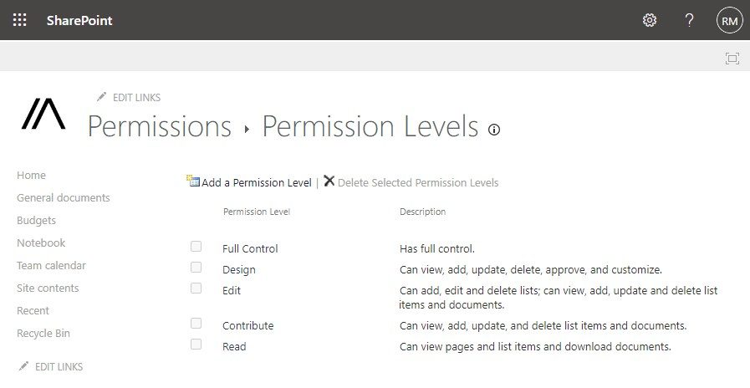

So as mentioned, it’s possible to create your own permission levels. To do this, click on settings (gear icon) in the top right corner and select **Site permissions** > **Advanced Permissions**.

n the permissions tab, click on **Permissions Levels**:

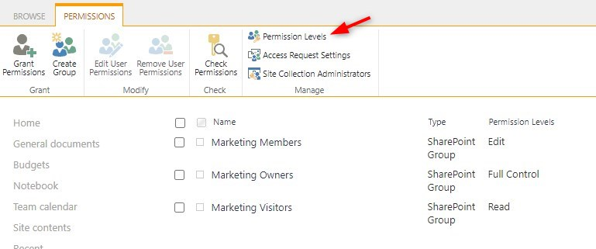

All the existing permissions levels are listed here. It’s best practice to not change the existing permissions levels but instead **add a new permissions level**.

We can now select the permissions that we want to assign. As you will notice, when you select a permission, other options are automatically selected as well. For example, when we choose to **Create Alert**, then View Items, View Pages and Open are also selected. These extra permissions are needed so the user can access the site and view the libraries.

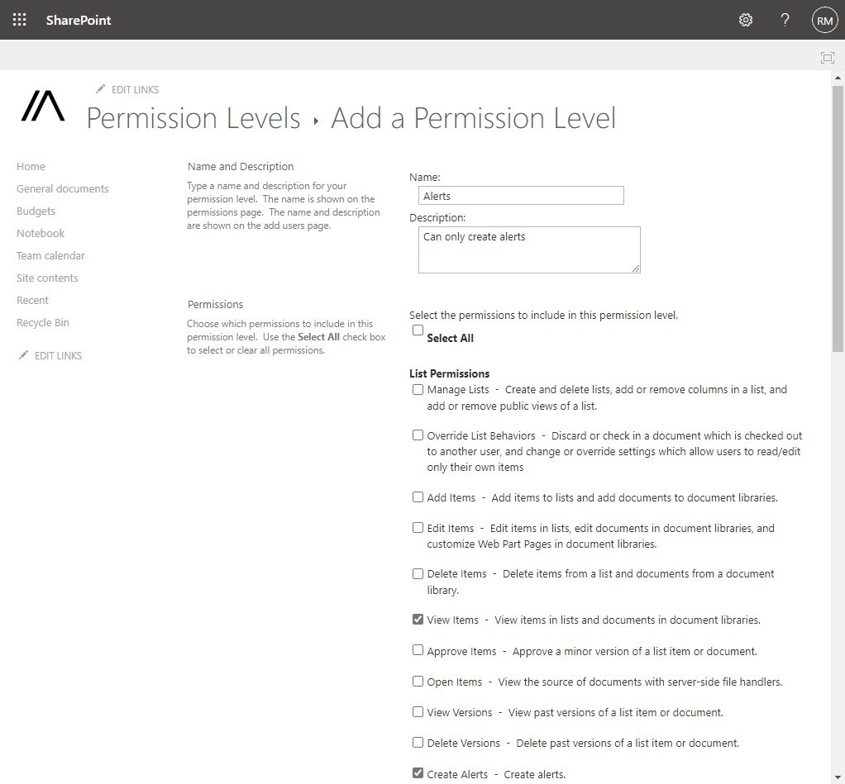

Creating custom permission levels

**Site Permissions**

The first place to change permissions for a SharePoint site is the site permissions. This will allow you to set the security setting at site level, affecting all document libraries, lists, pages, etc. Permissions should always be set with the Principal of least privileges in mind. Don’t give users more permissions than they need.

To change the site permissions we will need to open the **settings menu** (gear icon) and click on **Site Permissions:**

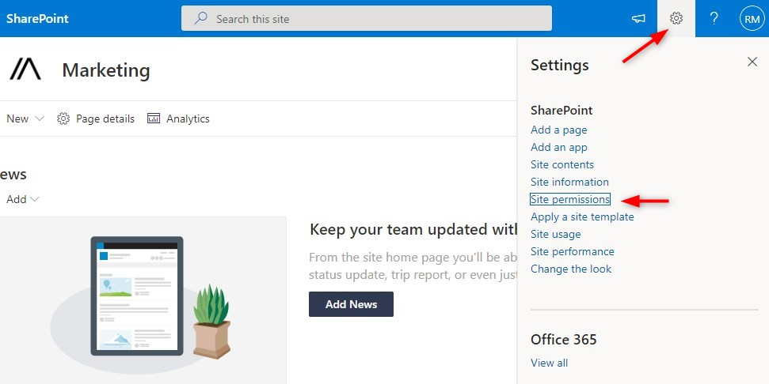

This will show the basic permissions and allows you to add members and owners to the site. Click on **Add members**(1) to add users to the site. Here you can look up users and make them Members or Owners of the SharePoint site.

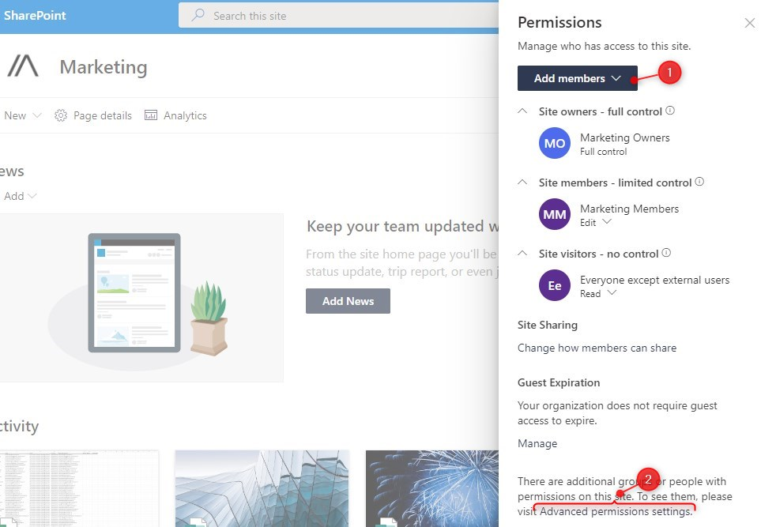

Another option is to use the **Advanced Permissions Settings** (2). The advanced settings allow you to choose custom permission levels and add groups of users (security groups) to the SharePoint site.

1. Click on **Advanced Permissions Settings** in the screenshot above (2)
2. Click **Grant Permissions**
3. Search for users or security groups. You can add multiple groups or users simoultancyly
4. Select **Show Options**
5. By default, the users will receive an invitation email. You can turn it off if you want
6. **Select the permission level**that you want to assign.
7. Click Share to grant the permissions.

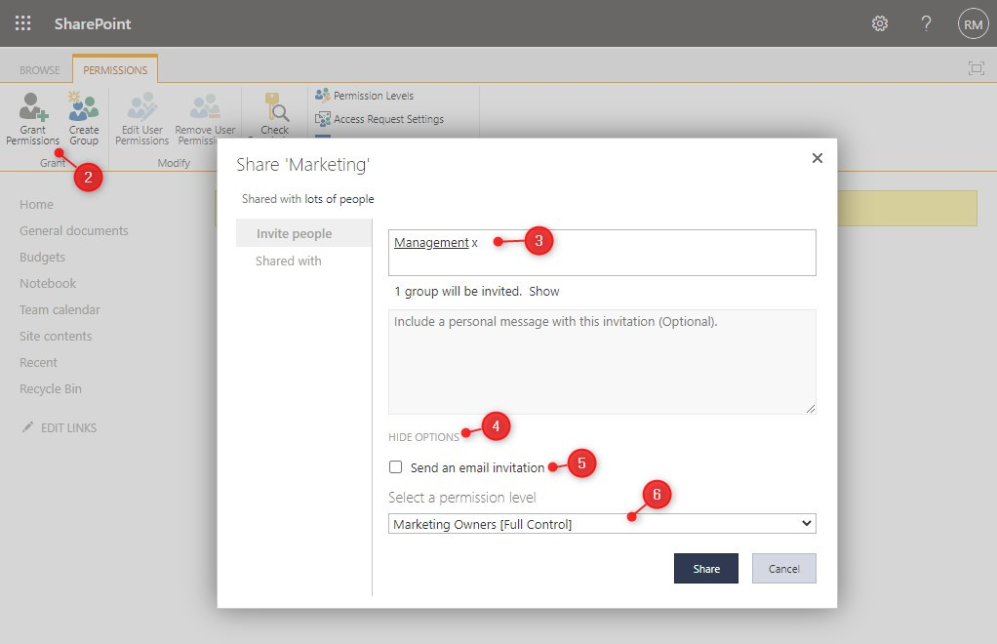Adding permissions

**Creating Custom Groups**

By default, you can only add users or groups to the default security groups (owners, members, visitors). But it’s also possible to create your own security groups. Each group can be assigned one or multiple permission levels.

Click on **Create Group** in the Advanced Permissions settings:

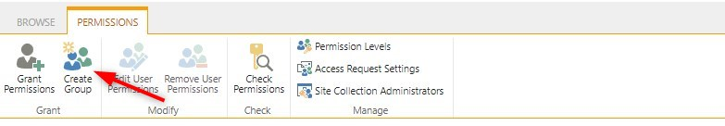Create Group

Give the group a meaningful name and select who can view and add members to the group. At the end of the settings page we can choose the permission level that we want to assign to the group members, for example, Restricted view:

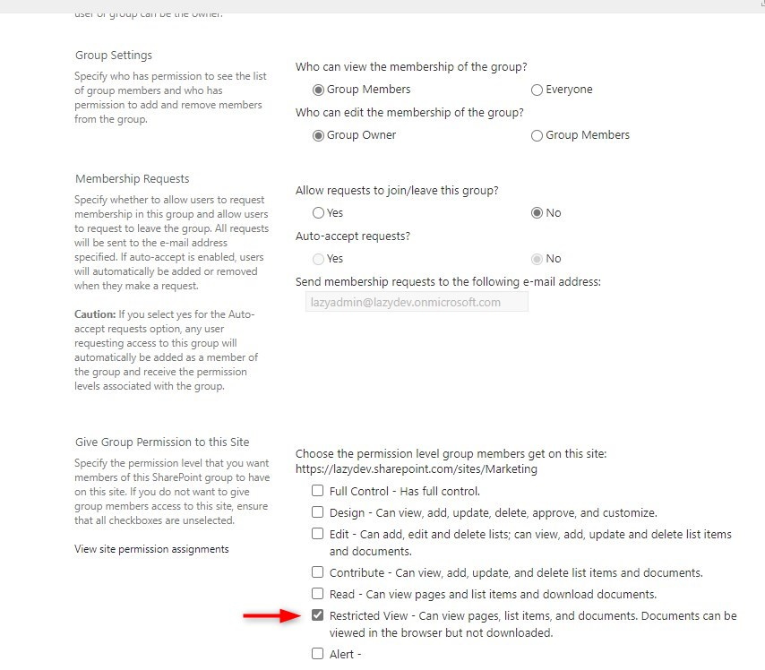

After you have created the group, we can go back to the permissions page and assign users to our newly created security group:

